Contenido

0.- GAME SPECIFICATION 3

1.- PLANNING GAME 3

1.1.- RELEASE 1 (HELLO WORLD) 3

1.2.- RELEASE 2 (1, 2, 3, ACTION!) 4

1.3.- RELEASE 3 (NO PAIN, NO GLORY!) 5

2.- CLASS DIAGRAM 6

3.- PROBLEMS AND SOLUTIONS 7

3.1.- RELEASE 1 7

3.2.- RELEASE 2 7

3.2.- RELEASE 3 7

4.- CONCLUSIONS 7

# 0.- GAME SPECIFICATION

Basically the game is composed by our Main Character (The hero), a bunch of enemies and a base that we must to protect. If you die or the base get destroyed by the enemies you will lose. The enemies keep going in waves to the base so you cannot actually win. There are some Power-ups that you can get in order to increase your character’s attributes.

# 1.- PLANNING GAME

# 1.1.- RELEASE 1 (HELLO WORLD)

* Starting date: 5 of november (approximately).
* Ending date: 17 of november (maybe a little bit earlier).
* Main Contributions:
  + Aleix - Graphical game Menus, Collider script, Player Health display.
  + Jose - World display, Terrain Script, Player movement.

*Terrain script involved loading only what the player could be able to see.*

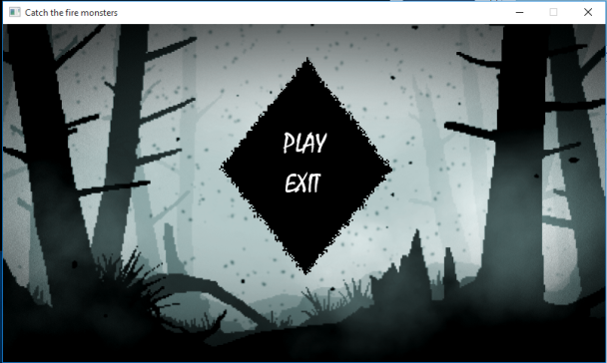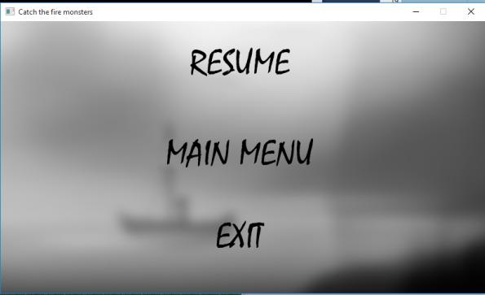

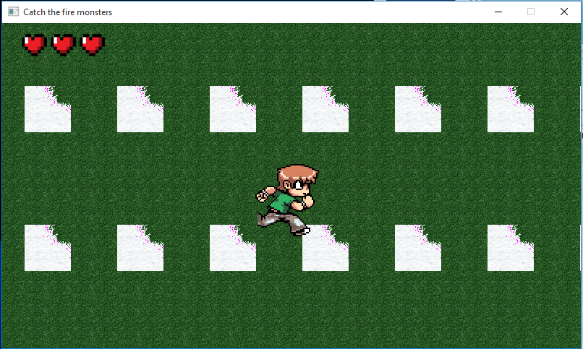

# 1.2.- RELEASE 2 (1, 2, 3, ACTION!)

* Starting date: 1 of December (approximately).
* Ending date: 20 of December.
* Main Contributions:
  + Aleix – Object Class , Inventory management, animation improvement, Objectlist.
  + Jose – Character Class, Template classes, CharacterList , Pick up management.

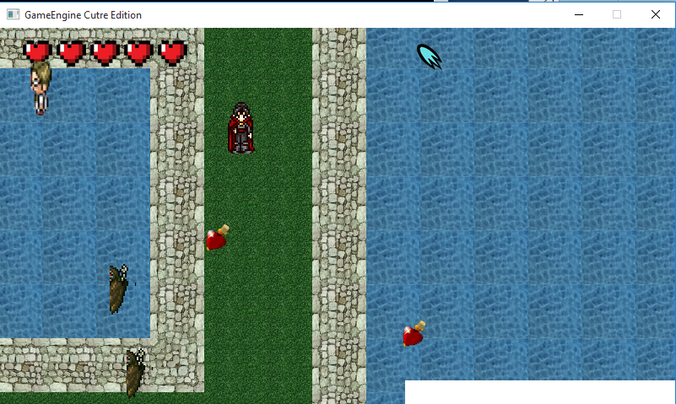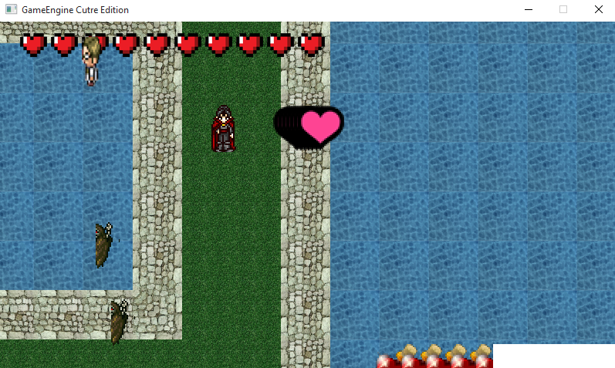

# 1.3.- RELEASE 3 (NO PAIN, NO GLORY!)

* Starting date: 7 of January.
* Ending date: 14 of January.
* Main Contributions:
  + Aleix – Ranking scripts , Scenes Quality improvement, Animations.
  + Jose – Save / Load files management. Smart Behaviour

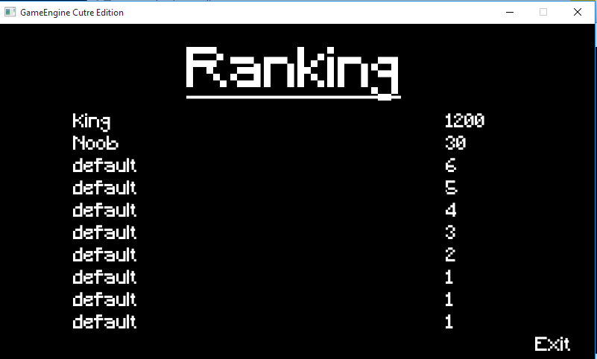

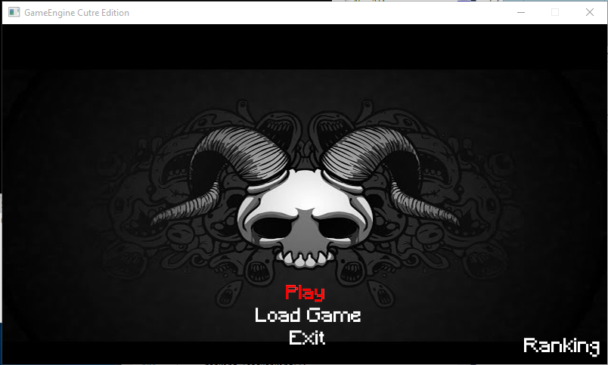

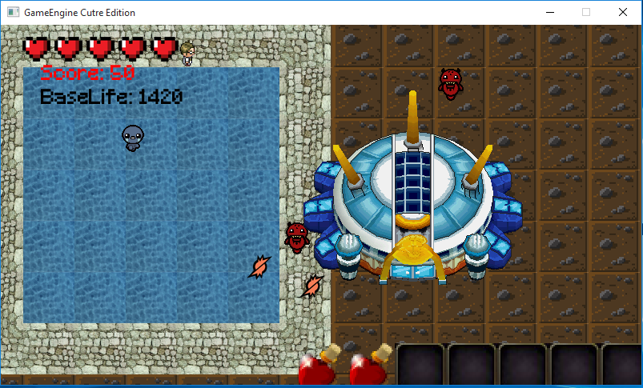

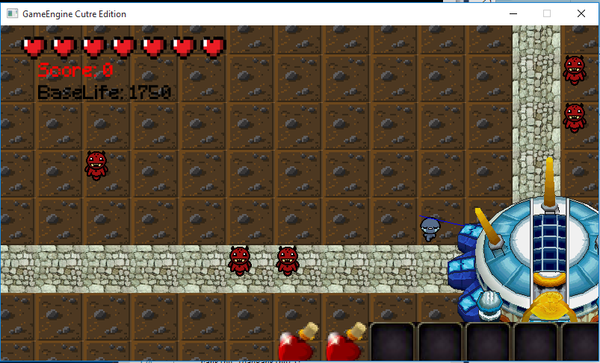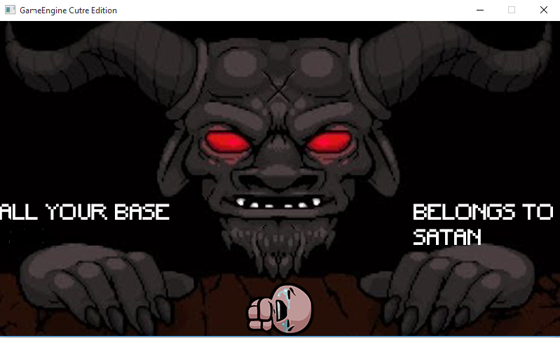

# 2.- CLASS DIAGRAM

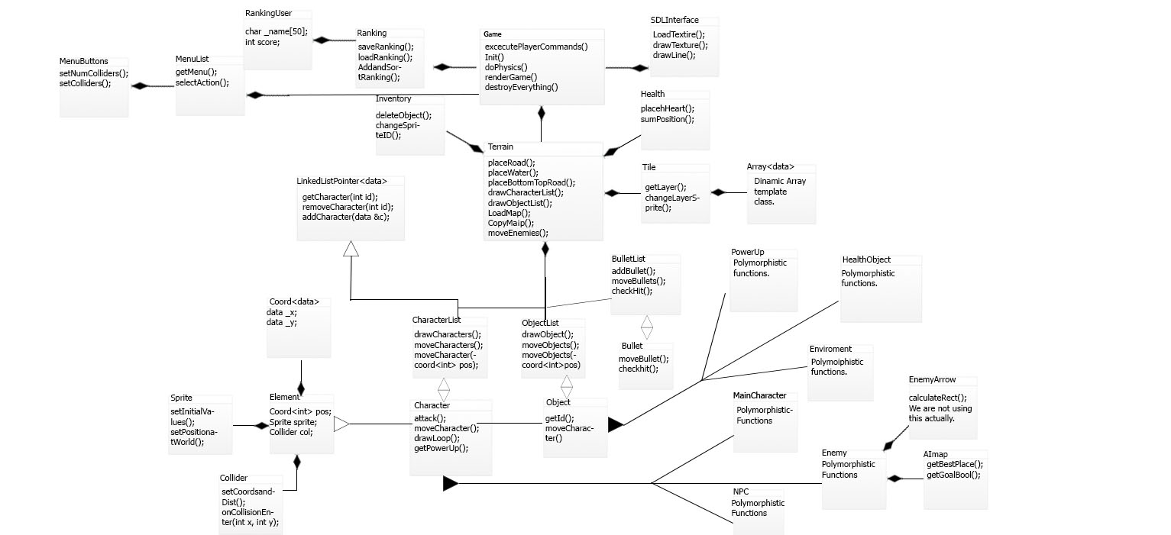

*Original image added in the .zip file for having the real scale of the image.*

# 3.- PROBLEMS AND SOLUTIONS

# 3.1.- RELEASE 1

We originally had trouble with the camera as we didn’t know how to make the movement effect, finally we figured out that we only had to move the terrain in the opposite direction of the character, without moving the character at all.

# 3.2.- RELEASE 2

We started having trouble with the polymorph inheritance at the beginning, thing that we solved pretty much quickly. The big trouble we had was with the way that we were using the Main Character and all his attributes, so in the end we had to change everything to keep the Main Character in the list, that gave us a lot of rework in the code. But in the end we solved everything with a few of bugs, like killing the characters and getting objects.

# 3.2.- RELEASE 3

The first trouble we had was with the binary files, but was solved pretty quickly. After that , we solved some problems from the release 2. The main trouble we had with this release was with the implementation of the AI, because we had to change our way of drawing the enemies and that took us a lot of time. With the ranking we had some trouble, but in the end they were small things and were easily to solve. The release still have some troubles, with a few of things.

# 4.- CONCLUSIONS

A reflection about your development and your progress:

* We’ve improved our programming skills a lot and learned a bunch of new features, on the other hand we’re regretful for not starting the release 3 earlier.

If you feel satisfied with the final result:

* Well, as we said before we feel regret, however we have worked hard, and we think that we’ve done a good work, although could it be better.

In your opinion, what are the most difficult and easiest tasks:

* For us, definitely the hardest part has been the implementation of Artificial Inteligence, because of our lack of knowledge in this field. Another hardest part of our development could be easily the change that we had to do with the Main Character, fitting him into the list, was a big change in the code. The easiest part for us could be the implementation of new data structures, because although our lack of knowledge we had a lot of examples from classroom and stuff like that.

In your opinion, what are the strengths and weakness of your development.

* At the beginning we used to make everything to be dynamic, I mean before we started coding, we thought the way to make something universal, and with different ways of use, that could be our most valuable strength. On the other hand, our biggest weakness could be the lack of time and the lack of AI knowledge, that made our stupid minds to destroy some parts of the code and to have to remake it.

If you could back to the past, would you did something different?

* Definitely, first of all, We’d change the idea of the game, to be honest, we didn’t know what to do at the beginning of the Project we thought : “Let’s be developing the game and we’ll find out an idea later”. The problem with that is that we developed things that aren’t used nowadays in the current version of the game. And we would have given ourselves more time to finish perfectly the release 3.

If you could add new elements into the game, what will you add it?

* First of all, We’ll try to solve everything to make the game, a very solid game. After that we think we would implement the feature of the NPC selling us objects, such as torrets, that we could use it to put them near the base and help you to defend the base. But as we said before we would first solve the big problems that it has.